**ntroduction**:

In this project we want to share with you the experience of developing a parking assistant system using arduino uno and ultra-sonic sensor and a buzzer.

Functionalities offered by the device are: measuring the distance between the sensor and the nearest object and issuing a buzzer sound depending on the distance (bip sound changes according to the distance), we can also measure the speed of the moving object by calculating the distance at two different points in time then finding the average speed, since speed $=\frac{Distance}{Time}$.

**Parts required:**

Arduino uno

Ultra-sonic sensor ()

Buzzer

Protoboard

Batteries (for power saving strategy)

Cables.

**Connections diagram:**

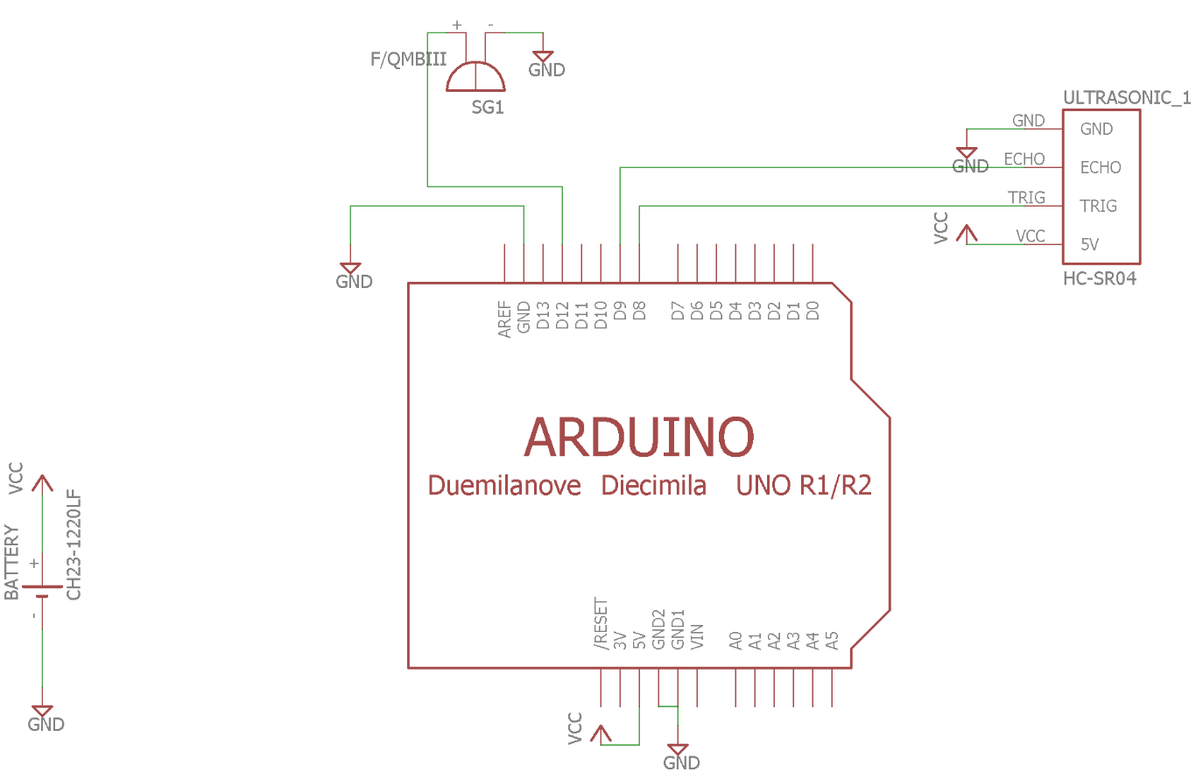

**Flow chart of the sensor:**

Echo Received

Object out of range

Yes

Get Distance i

No

**Constraint:**

**Ultarsonic sensor (HC-SR04)**

- Max Range 4m

- Min Range 2cm

- Accuracy 3mm

**Buzzer frequency range**

261HZ (Delay 300ms) -150cm—90cm

261HZ (Delay 200ms) -90cm-----30cm

261HZ (Delay 100ms) -30cm-----2cm